www.westernsnowconference.org Updated February 22, 2013
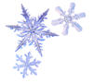WESTERN SNOW CONFERENCE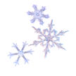

Jackson Hole Technical Tour - Thursday, April 18, 2013
Wildlife and Snow Hydrology Bus Tour
Leave: Snow King at 8:30 am Return: to Snow King 4:30 pm

Phil Farnes will be your trip guide and narrator along with Alltrans Charters, wildlife experts, and other local characters such as Mike Beus USBR Upper Snake Operations, and Bodean Barney, Wyoming State Engineers Office and 3rd generation native in the valley. This is an once-in-a-lifetime tour that is not available anywhere else. Phil spent a lot of his career studying the snow and interactions with wildlife and vegetation in the greater Yellowstone area. Come and learn about these relationships and how they may help you better understand what is happening in your own backyard.

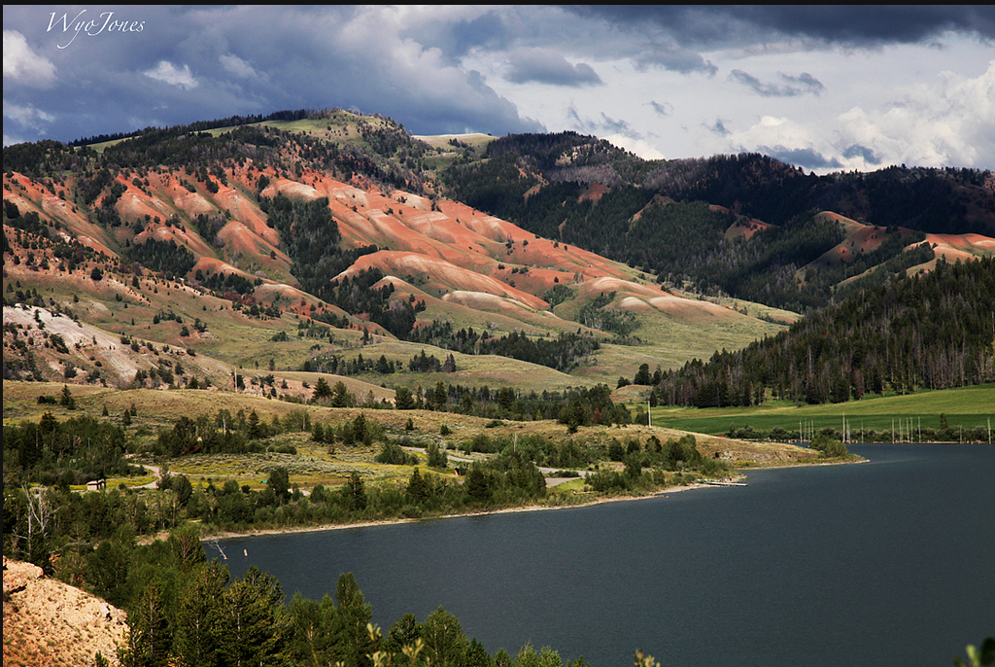
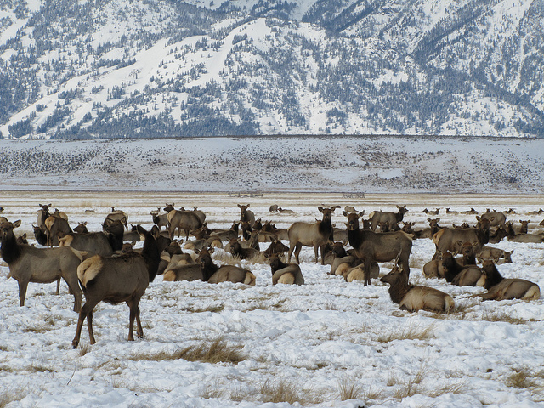
- National Elk Refuge at edge of Jackson - Depending on green-up Elk and Bighorn Sheep may have migrated up country or may still be around. Turnouts on road offer great views of the Tetons.
Wintering Elk Herd near Jackson Lower Slide Lake

- Trip to Gros Ventre Slide - The slide happened in June 1925 forming Slide Lake across Gros Ventre River that broke in May 1927 and killed six people in Kelly. Kelly Warm Spring is interesting because the early Mormon settlers diverted water from the Gros Ventre River and ran it about 2.5 miles to reach that spring. Ditches carry water another 2-3 miles to the Mormon Row homesteads where they have a ~60-day growing season and since the spring stays warm year-round helped to extend the growing season a bit.

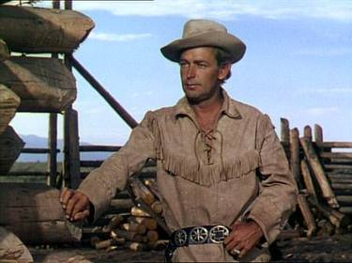
- Along the way, you’ll get a good view of Tetons and location where much of the western movie Shane was filmed (Alan Ladd, Jack Palance, Van Hefflin). Django Unchained is a 2012 American epic western film written and directed by Quentin Tarantino. The film stars Jamie Foxx, Christoph Waltz, Leonardo DiCaprio, Kerry Washington, and Samuel L. Jackson and was released on December 25, 2012 in North America.

- We’ll also go through Antelope Flat which is a big game wintering area.
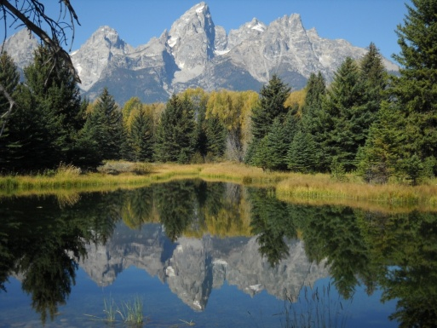
- Schwabacher Landing - Outstanding view of Tetons with reflection in the beaver pond.
- Head north for buffet lunch at Heart Six Ranch 4 miles east of Moran Junction. Cabins available to extend your stay in the valley.
- Oxbow Bend turnout - Another great photo location of Mt. Moran and Snake River. Possible moose and swans in area.

- Jackson Dam and informational discussion about the dam and history - Did you know that Wyoming uses only about five percent of the Snake River water while Idaho uses most of it where the climate is more ideal to grow crops.
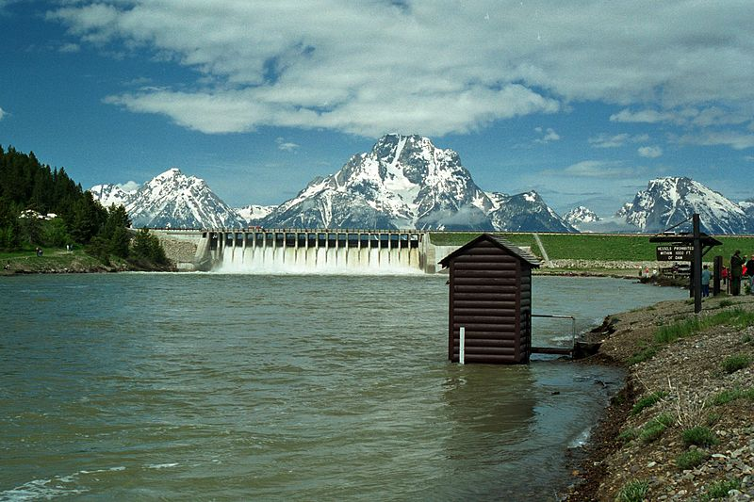
- South to Jenny Lake/String Lake if roads are open. More photo areas.
- South to Moose Visitor Center (Grand Teton National Park) - Newer facility worth viewing includes many new displays, bookstore, and 23 minute video. Return to Jackson via Teton Village which is at the base of Jackson Hole ski area if roads are open.
- Link to Grand Teton Historic Resource Study – A Place Called Jackson Hole

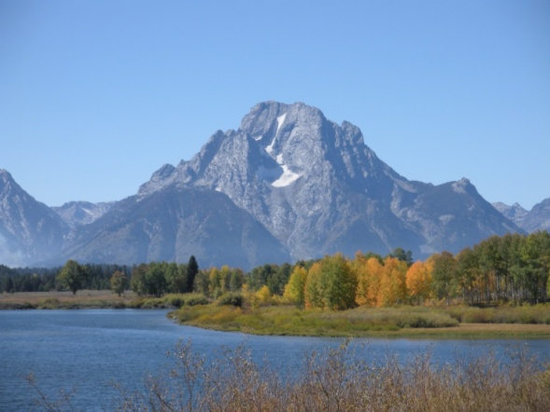
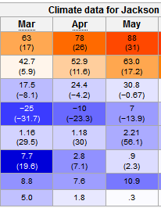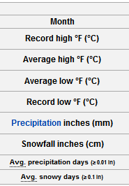
If you have a late afternoon or evening flight, we can make arrangements to drop you off at the airport around 4pm. Bring warm clothing for time not spent on the bus.

For registration, cost and additional information, see the Western Snow Conference website or contact Ron Abramovich Bruce McGurk or Bodean Barney
http://www.westernsnowconference.org/2013.html

Spouse Tour - Wednesday, April 17
Meet at 9:30 Grand View Lodge

- Morning Jackson Valley and Yellowstone Visitor’s Center in Jackson

- Lunch and exhibition viewing at National Museum of Wildlife Art

- Afternoon walking and shopping around Jackson

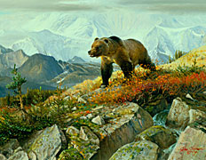

Lewis Falls on the Lewis River in Yellowstone National Park January 16, 2013
